Schedule of activities – CPU summer school

Students will meet at HW 113/114 where they will be collected by the lead member of staff. This will be your referral point for your time at Strathclyde.
- Classes normally start at 9:00 and end at 5:00 (with the exception of the English classes on the 18th & 19th which end at 5.30pm)
- There is a comfort break every day from 10:00 – 10:30
- Refreshments can be bought at various locations on campus and consumed in the various social areas
- Lunches are served at 12:00 (venues detailed below).
- Afternoon sessions start at 2:00
 | 9:00-11.45 | Learning objective | 2:00:500 | Learning objective | Staff involved
Lunch Venue
Mon 8th July | Welcome 9:00-10:00, Safety 10:30- 11:30 (HW113/114)  Campus tour 11:30 -12:00 | Familiarisation with UoS and laboratory safety | Visit to library 2:00-3:00, English language class 3:00-5:00 - students allocated groupings (HW323 & HW324 & HW113) | Accessing literature (library  English language and critical reading | Annette Sorensen (campus tour) Lorraine Allan (safety) Library (Lorna Gilkison | Research & Learning Support | Andersonian Library) Ben Brown/ Gemma Archer (English)
Tue 9th July | Immunology  Laboratory | Understanding how a Biological procedure unit operates and how to determine the numbers of parasites in a sample. | Immunology  Workshop activity  English language class 3:30-5:30 - students allocated groupings (HW323 & HW324) | Presentation skills of scientific data from selected papers  English language and critical reading | Linda Horan  Chris Carter  Catherine Lawrence  Ben Brown/ Gemma Archer (English)
Wed 10th July | Immunology  Laboratory | Understanding the role of the immune system in conferring immunity to parasitic infection: discussions. | Immunology  Workshop activity  English language class 3:30-5:30 - students allocated groupings (HW323 & HW324) | Critical appraisal of scientific data: paper interpretation: Immunity to parasites:  English language and critical reading | C Lawrence  C Carter  Ben Brown/Gemma Archer (English
Thur 11th July | Pharmacy | To understand: NHS and Pharmacy infrastructure, MPharm undergraduate teaching  Herbal Medicines use in UK | Practical Session in dispensary | To understand: How to label medicines and dispense medication against a prescription | Ian Towle Plus Ann Mitchell
Fri 12th July | Glasgow local Holiday | Glasgow local Holiday | Glasgow local Holiday | Glasgow local Holiday | Glasgow local Holiday
Lunch Venue
Mon 15th July | Glasgow local Holiday | Glasgow local Holiday | Glasgow local Holiday | Glasgow local Holiday | Glasgow local Holiday
Tue 16th July | Physicochemical properties (DGW) | Understand and appreciate ionisation and lipophilicity of drug molecules and how this affects their properties. | Chromatography (DGW) | Understand what chromatography is.  Appreciate the basic principles of high performance liquid chromate-graphy (HPLC), in particular reversed-phase chromatography.  Understand the basics of electrospray LC-MS | Dave Watson
Wed 17th July | LC/MS lab (DGW) | Understand and apply how chromate-graphic techniques can be used to analyse paracetamol in tablets and how LC-MS can be used to identify degradants. | LC/MS lab (DGW) | Understand and apply how chromate-graphic techniques can be used to analyse paracetamol in tablets and how LC-MS can be used to identify degradants | Dave Watson
Thur 18th July | LC/MS lab (DGW) | Understand and apply how chromate-graphic techniques can be used to analyse paracetamol in tablets and how LC-MS can be used to identify degradants. | LC/MS lab (DGW) | Understand and apply how chromate-graphic techniques can be used to analyse paracetamol in tablets and how LC-MS can be used to identify degradants. | Dave Watson
Fri 19th July | LC/MS lab (DGW) | Understand and apply how chromate-graphic techniques can be used to analyse paracetamol in tablets and how LC-MS can be used to identify degradants. | LC/MS lab (DGW) | Understand and apply how chromate-graphic techniques can be used to analyse paracetamol in tablets and how LC-MS can be used to identify degradants. | Dave Watson
Sun 21st July | 10am Stirling Castle Ross Priory, | Stirling Castle, Ross Priory, Loch Lomond | Stirling Castle, Ross Priory, Loch Lomond | BBQ Ross Priory | BBQ Ross Priory
Lunch Venue
Mon 22th July | Pharmacy  Series of presentations on: | To understand:  Clinical Pharmacy and extended role of pharmacist  Student presentations on herbal medicine | Practical Session in dispensary | To understand: How to check blood pressure  Apply evidence to managing patients with hypertension | Ian Towle and Ann Mitchell
Tue 23rd July | Practical Session in dispensary | To use Simman and other tools to understand management of cardiovascular and respiratory conditions  To learn and Medicines Recon | Practical Session in dispensary | Understand  concept of accuracy checking of prescriptions and use of communication skills to educate patients | Ian Towle, Pernille Sorensen and Louise Evans
Wed 24th July | Highland trip 8am-8pm
Thur 25th July | Biochemistry  3rd year enzyme kinetics lab | 3rd year enzyme kinetics lab | Luke Chamberlain  3rd year enzyme kinetics lab analysis and discussion | Understand enzyme kinetics and data analysis | Luke Chamberlain
Fri 26th July | Biochemistry (lab)  Green Fluorescent Protein:  1.Make a 3D model of GFP  2.Streak out GFP cells on agar plates  3. Determine the results of complex interactions of fluorescent proteins in cells. | The understanding that molecular tools such as GFP can make an enormous contribution to the scientific understanding of biological processes. | Biochemistry  Lorenzo’s oil film and quiz  Can I get the cal lab? | Understanding the link between a genetic condition and its therapy. | Ben Pickard
Lunch Venue
Mon 29th July | Cancer biology  Lecture/tutorial | Understand the principles of cancer, how and why it occurs, what it looks like and how its treated | Cancer workshop  Students in groups develop their own campaign and present to the whole class. Cancer quiz | Develop and critically appraise cancer prevention advertising campaigns. | Marie Boyd  Annette Sorensen
Tue 30th July | 9:00-9:05 Introduction to the day and the team  9:05-9:30  What is Industrial Biotechnology and why is it important?  9:30-10:30  IB in Scotland  11:00-11:30  Careers in IB  11:30-12:30  Guest Industry lecture | Understanding Industrial Biotechnology | 14:00-15:45  Three workshops:  •YSI demo  •Meet the students  •RBPC tour | Instrument set up in a separate (larger) lab. Short demos by Russell at YSI  Meet the students: Three interns in a booked room giving short presentation of their route to IB, how they got there and why with rooms for Q&A  RBPC Tour: Tour of IBioIC with short demos on some kit that is currently working. | Rachael Moir
Wed 31th July | Pharmacology  Pharmacology lecture  9:00- 10:00  10:30 – 12:30 (Cal lab – GPI simulation) | Understand the principles of pharmacology and the construction of CRC with and without an antagonist | Pharmacology  In vitro laboratory  (2:00 -3:00) Lecture – Lab preparation  (3:00- 5:00) In lab | In Vitro Pharmacology  Calculate EC50s | EGR
Thurs 1st Aug | CPU Student presentations (what they enjoyed and learned) | Presentation and communication skills | CPU Student presentations  (what they enjoyed and learned) | Presentation and communication skills | EGR – all staff welcome
Fri 2nd Aug | Graduate from Summer School (individual certificates)

Below are the images of some of the staff that are involved in the summer school.

Prof Robin Plevin (Head of Institute)
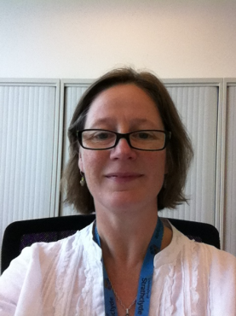 Dr Catherine Lawrence (Parasitology)
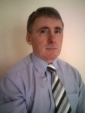 Dr Edward Rowan (Pharmacology)
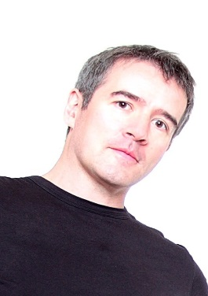 Prof Craig Roberts (Immunology)
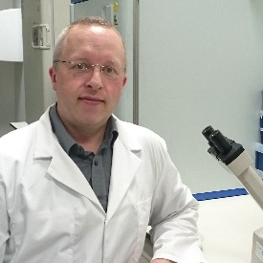 Dr Ben Pickard (Biochemistry)
Dr Chris Carter (Parasitology)
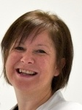Dr Marie Boyd (Cancer research)
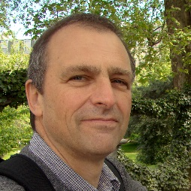 Dr David Watson (Analytical Chemistry)

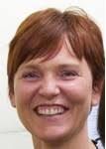 Dr Annette Sorensen

